**R&D Report on OSI Model**

The seven-layer Networking Communication Framework

Prepared by:

Virat Pandey

Celebal Technology

Cloud Infrastructure & Security Internship

Research & Development Document

June 8, 2025



# **Table of contents**

1. Introduction ............................................................................................ 2

2. Overview of the OSI Model .................................................................... 3

3. Layer-wise Explanation of the OSI Model ……...................................... 4

3.1 Physical Layer

3.2 Data Link Layer

3.3 Network Layer

3.4 Transport Layer

3.5 Session Layer

3.6 Presentation Layer

3.7 Application Layer

4. Summary table ..................................................................................... 9

5. Conclusion ............................................................................................ 10

7. References ........................................................................................... 11



# **Introduction**

Every time we send a message, browse a website, or connect to a cloud service, we rely on networks working silently in the background. But what really makes these systems talk to each other smoothly? That’s where the **OSI Model** comes in a framework designed to make complex communication systems understandable and manageable.

The **Open Systems Interconnection (OSI) Model**, developed by **ISO**, divides the networking process into **seven logical layers**, each with its own responsibilities from physical data transmission to application-level interactions. Instead of trying to manage an entire system as one giant block, the OSI approach encourages modular thinking: build, troubleshoot, and scale by layer.

This R&D report takes a close look at the OSI Model not just as a theoretical concept but as a tool used in real world network design, troubleshooting, and security. In the context of cloud infrastructure, where systems must be fast, reliable, and secure, understanding how each layer functions are essential.

By exploring each layer individually, this report builds a practical perspective on how data flows through a network and why this model still matters today, especially in cloud projects like the one I’m currently contributing to during my internship at **Celebal Technology**.

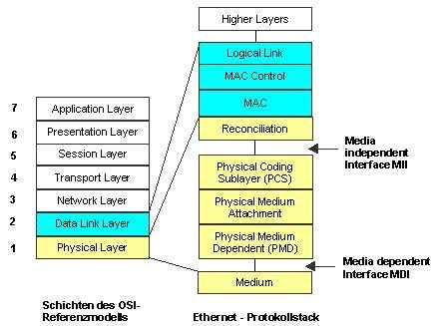

# **Overview of the OSI Model**

The **OSI (Open Systems Interconnection) Model**, introduced by the **International Organization for Standardization (ISO)**, is a conceptual framework that defines how different networking components should communicate over a network. While working through Microsoft Learn's networking fundamentals module, I came across a simple yet effective explanation:

*"Each layer offers specific services to higher layers while shielding these layers from the details of how the services are implemented."* — Microsoft Learn [[1]](https://learn.microsoft.com/en-us/windows-hardware/drivers/network/windows-network-architecture-and-the-osi-model)

This quote helped me understand that the OSI Model doesn't just describe how data moves, it organizes the process in a way that makes it **modular, manageable, and interoperable**. That is, engineers and systems can work independently on different layers without affecting the whole architecture which is especially useful in **large-scale cloud and enterprise networks**.

The model is made up of **seven logical layers**, with each layer having its own responsibilities from raw physical transmission of bits to end user applications. According to Microsoft Learn, this structure **"allows network administrators to isolate issues and troubleshoot more effectively"**, which is a crucial skill in managing modern cloud infrastructure and security.

Even though real-world systems mostly follow the TCP/IP model today, the OSI model still remains a **key teaching tool** and helps build a strong foundation for understanding protocols, devices, and security implementations. It’s particularly useful in environments like mine, where cloud architectures, firewall rules, and layered security policies depend on understanding how data flows across layers.

# **Layer by Layer Explanation of the OSI Model**

To help memorize the seven layers of the OSI Model, the popular mnemonic is:

**“Please Do Not Throw Sausage Pizza Away”**

where each first letter corresponds to a layer from Layer 1 to Layer 7: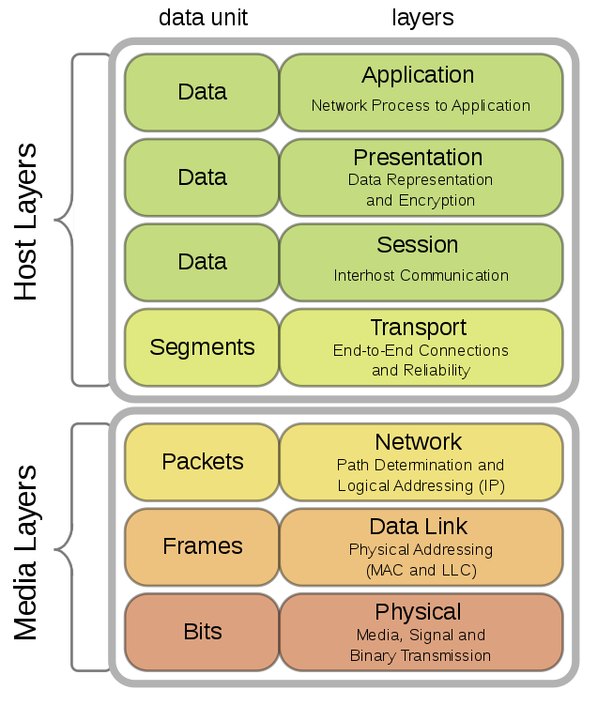

* **P**hysical
* **D**ata Link
* **N**etwork
* **T**ransport
* **S**ession
* **P**resentation
* **A**pplication

This simple sentence aids in recalling the order and names of the layers easily.

Now let’s study and have a better understanding of these Layers one by one ➡️

### **3.1. Physical Layer (Layer 1)**

This is the **foundation** of the OSI Model. It handles the actual **transmission of raw bits** (0s and 1s) over a physical medium like cables, switches, or wireless signals.

* **Function:** Responsible for **voltage levels**, **data rates**, **cabling**, **connector types**, etc.
* **Devices involved:** Ethernet cables, hubs, fiber optics, repeaters.
* **Real-world example:** When you plug in an Ethernet cable, you're using the physical layer.

*“The Physical Layer transmits raw bits over a physical data link connecting network nodes.”* — Microsoft Learn [[1]](https://learn.microsoft.com/en-us/windows-hardware/drivers/network/windows-network-architecture-and-the-osi-model)

### **3.2. Data Link Layer (Layer 2)**

The **Data Link Layer** ensures **error-free transfer of data frames** between two devices connected on the same network. It organizes raw bits into frames and handles **physical addressing (MAC addresses), error detection, and flow control**. This layer is essential to create a reliable link despite physical layer noise.

Common devices operating at this layer are **switches and network interface cards**. For example, when your laptop connects to a router via Wi-Fi, Layer 2 handles addressing and controls how data is sent and received to prevent collisions.

“The Data Link Layer establishes and terminates connections between two physically connected nodes.” — Microsoft Learn [[1]](https://learn.microsoft.com/en-us/windows-hardware/drivers/network/windows-network-architecture-and-the-osi-model)

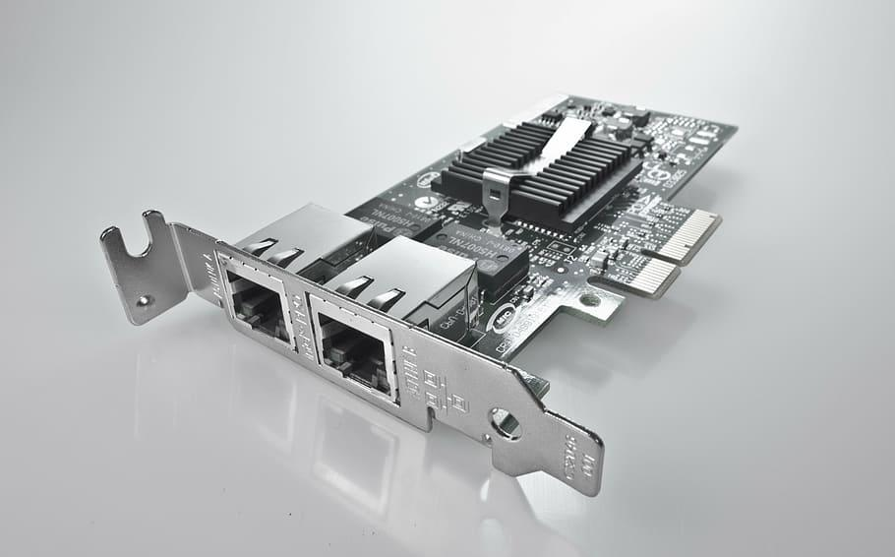

### **3.3. Network Layer (Layer 3)**

The Network Layer routes data across different networks. It gives devices an **IP address** and figures out the best path for data to travel to its destination. That is the minimal ways without loss

* 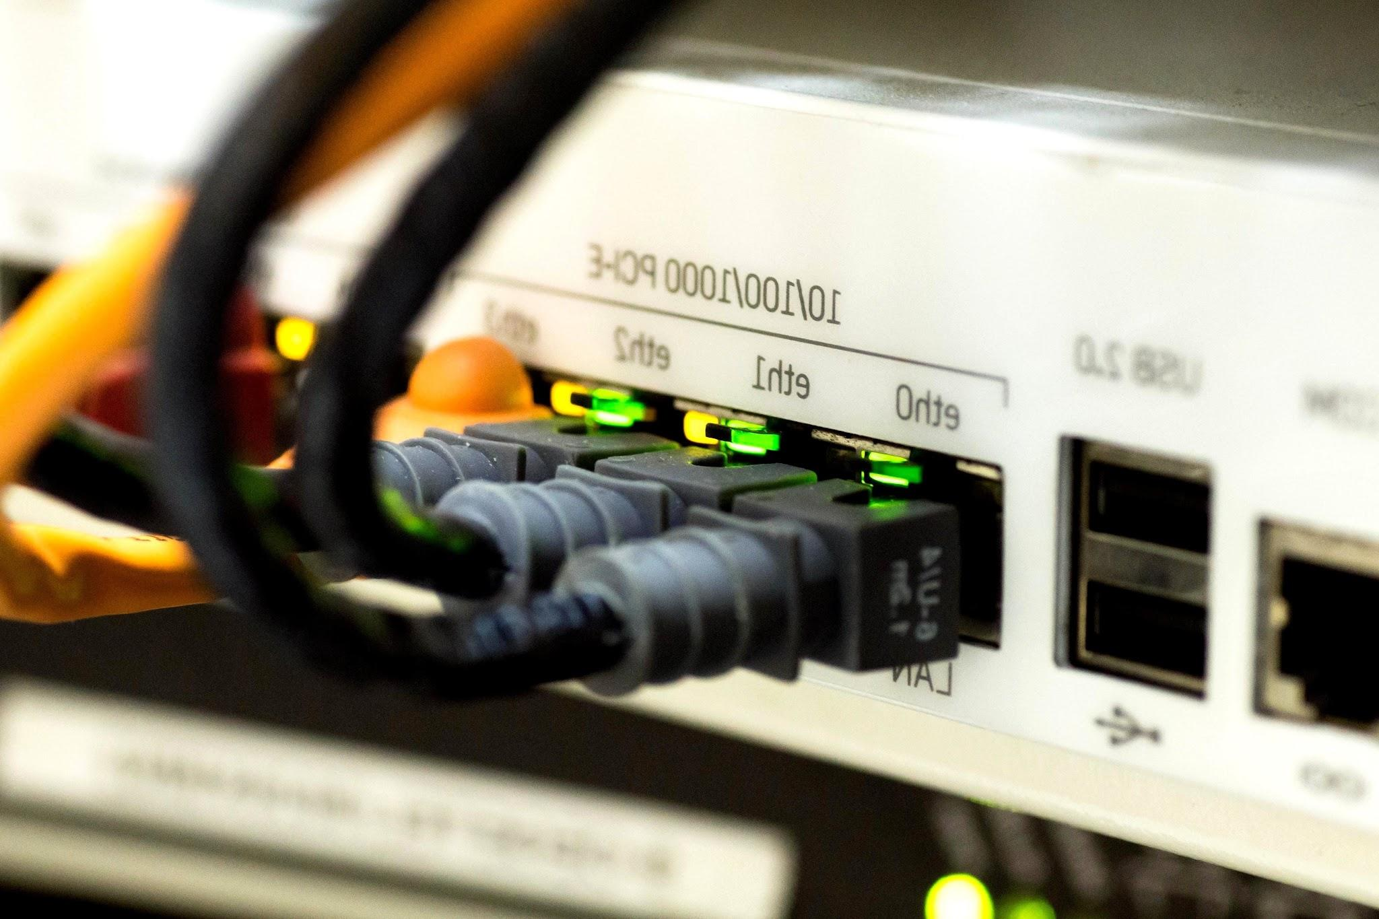**Main role:** Logical addressing, routing data packets
* **Devices:** Routers
* **Protocols:** IPv4, IPv6, ICMP

* **Example:** When you send an email or open a website, this layer ensures your request travels across multiple networks (via routers) to reach the right server.

This layer is also responsible for **fragmenting and reassembling packets**, meaning if a data packet is too big for a particular network, it gets broken into smaller parts and reassembled on the other side.

"The Network Layer is responsible for packet forwarding, including routing through intermediate routers." — Microsoft Learn [[1]](https://learn.microsoft.com/en-us/windows-hardware/drivers/network/windows-network-architecture-and-the-osi-model)

Without this layer, communication would be limited to local devices only the Network Layer makes the **internet truly global** by allowing data to travel across diverse and complex paths.

### **3.4, Transport Layer (Layer 4)**

This layer ensures data travels from one device to another **reliably or quickly**, depending on the protocol used.

* **Main role:** Segment data, manage error correction and flow control
* **Protocols:** TCP (reliable, ordered delivery), UDP (fast, no guarantee)
* **Example:** TCP keeps your WhatsApp messages intact, UDP streams live video fast but without perfect accuracy

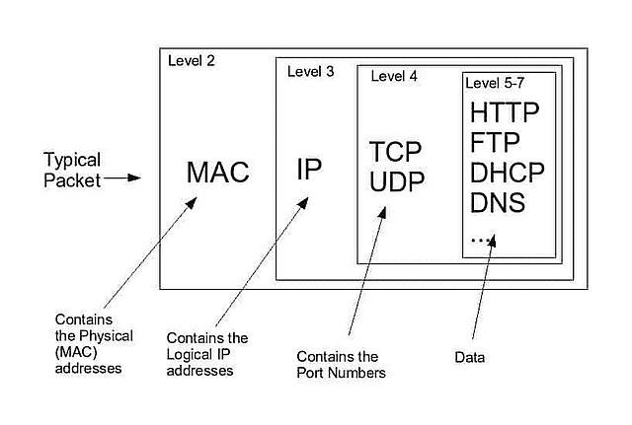

### **3.5. Session Layer (Layer 5)**

The Session Layer manages **the start, control, and end of conversations** (called sessions) between two devices. Whether it’s a short interaction like downloading a file or a longer one like a Zoom call, this layer ensures that the session stays intact and synchronized.

* **Main role:** Establishes, maintains, and terminates sessions between applications
* **Responsible for:** Session control, synchronization, dialogue management
* **Example:** During a Microsoft Teams video meeting, the session layer ensures that your connection stays alive, manages reconnections if interrupted, and synchronizes audio/video between participants

This layer also provides **checkpoints** or **synchronization points** so that if a session is interrupted (due to network failure, for example), it can resume from a known good point rather than starting over.

For instance, if you're uploading a file and the connection drops midway, the Session Layer might allow it to resume from where it left off instead of starting from the beginning.

"The session layer enables two applications on different computers to open, use, and close a connection, called a session." — Microsoft Learn [[1]](https://learn.microsoft.com/en-us/windows-hardware/drivers/network/windows-network-architecture-and-the-osi-model)

While it’s often invisible to users, its role is critical for smooth and uninterrupted application-to-application communication, especially for real-time and long-running interactions.

### **3.6. Presentation Layer (Layer 6)**

Often called the **“translator” of the OSI Model**, the Presentation Layer ensures that the data sent from one device can be **understood** by the other even if they use different formats internally. It also handles **data encryption, decryption, compression, and conversion**.

* **Main role:** Translate data formats, encrypt/decrypt data, compress/decompress content
* **Common tasks:**
  + Converting character sets (e.g., ASCII to Unicode)
  + Compressing files to reduce size
  + Encrypting data for secure transmission (e.g., using SSL/TLS)
* **Example:** When you open a secure HTTPS website, the Presentation Layer handles the TLS handshake and ensures the data you view is decrypted and readable

“The Presentation Layer ensures that data is in a usable format and is where data encryption occurs.” — Microsoft Learn [[1]](https://learn.microsoft.com/en-us/windows-hardware/drivers/network/windows-network-architecture-and-the-osi-model)

In short, it acts like an interpreter between devices, ensuring that what one sends, the other can make sense of while also **protecting and optimizing** the transmission.

### **3.7. Application Layer (Layer 7)**

The **Application Layer** is the topmost layer and the **closest to the end user**. It doesn't refer to the applications themselves but the services that applications use to communicate over the network.

* **Main role:** Provide network services directly to user applications
* **Key protocols:**
  + **HTTP/HTTPS** – for web browsing
  + **SMTP/POP3/IMAP** – for email services
  + **FTP/SFTP** – for file transfers
  + **DNS** – for resolving domain names to IP addresses
* **Example:** When you type a URL into your browser and press Enter, the Application Layer handles sending your HTTP request and receiving the web page response

It also handles **authentication, data requests, and resource availability**. Without this layer, users wouldn't be able to interact with networked services in any meaningful way.

“The Application Layer interacts with software applications that implement a communicating component.” — Microsoft Learn [[1]](https://learn.microsoft.com/en-us/windows-hardware/drivers/network/windows-network-architecture-and-the-osi-model)

In essence, it’s what lets us **send emails, browse the internet, access cloud storage, and more** all with just a few clicks.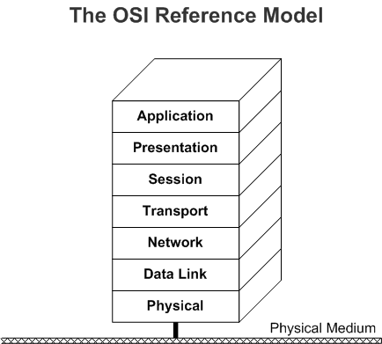

## **SUMMARY TABLE**

|  |  |  |  |  |
| --- | --- | --- | --- | --- |
| **Layer** | Layer No. | | Work | Application |
| Application | 7 | | User interface, network services | HTTP/HTTPS |
| Presentation | 6 | | Data format translation, encryption | SSL/TLS, JPEG, MP4 |
| Session | 5 | | Establish/manage/end sessions | Video call session, file transfer |
| Transport | 4 | | Reliable delivery, segmentation | TCP, UDP |
| Network | 3 | | |  | | --- | | Routing, logical addressing (IP) | | |  | | --- | | Routers, IP, ICMP | |
| Data Link | 2 | MAC addressing, frame transfer | | |  | | --- | | Switches, Ethernet | |
| Physical | 1 | | |  | | --- | | Bits transmission via hardware | | Cables, signals |

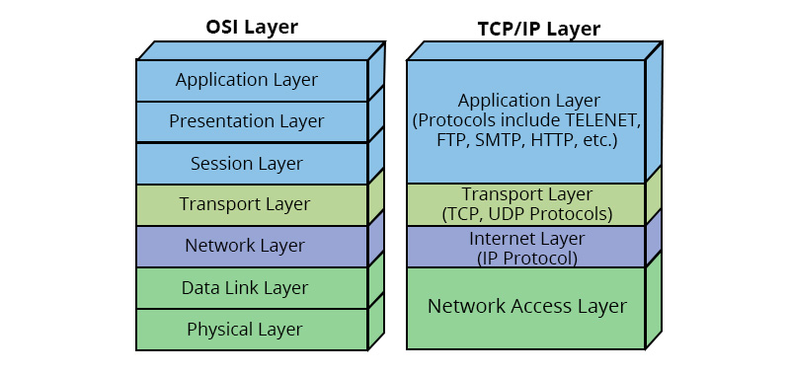

## **Conclusion**

The **OSI (Open Systems Interconnection) Model** remains one of the most important conceptual tools in the field of computer networking. It provides a structured way to understand and design how data travels from one system to another across different types of networks. By breaking down communication into seven distinct layers, the model simplifies what would otherwise be an extremely complex process. This layered architecture allows engineers, developers, and IT professionals to isolate, troubleshoot, and optimize specific aspects of network communication without affecting the entire system.

Each layer from the Physical Layer, which governs the transmission of raw bits over hardware, to the Application Layer, which interfaces directly with user applications plays a critical role in ensuring that communication is accurate, efficient, and secure. Understanding how these layers work individually and together is essential for maintaining the integrity and performance of modern network infrastructures, especially in the age of cloud computing, edge devices, and remote collaboration.

In real-world scenarios, even though most systems today rely on the TCP/IP model for implementation, the OSI Model serves as a **fundamental reference** for learning, analysis, and system design. It is especially useful in large-scale cloud environments where layered security, modular configuration, and systematic data handling are crucial.

As someone currently working on cloud infrastructure during an internship, I found the OSI Model incredibly helpful in grasping how data flows across network layers, where failures might occur, and how to approach design and security best practices from a foundational level. This model not only strengthens theoretical understanding but also supports the practical decisions that define modern IT systems. In summary, the OSI Model is not just a teaching framework it is a timeless tool that continues to guide professionals in building scalable, secure, and efficient networks.

## **Reference**

[[1]](https://learn.microsoft.com/en-us/windows-hardware/drivers/network/windows-network-architecture-and-the-osi-model) Microsoft. (2024). The OSI Model. Microsoft Learn. Retrieved from <https://learn.microsoft.com/en-us/windows-hardware/drivers/network/windows-network-architecture-and-the-osi-model>